he LAT, LON are in a confusing manner.

First, the geographical arrangement considering, LOW as smallest
latitude/longitude and HIGH as largest latitude/longitude.

HIGH,LOW ---------------- HIGH, HIGH
| |
| |
| |
| |
| |
| |
| |
LOW, LOW ---------------- LOW,HIGH

The data given in the original .mat file is ambigious.

N
W--E
S

--------------4.6KM----------------
|
|
2KM
|
|
-----------------------------------

Look into attached images for explanation.

So, after a lot of tweaking and correcting around, I've finally come up with an understandble format. If numpy arrays represnet a matrix like this,

(0,0)------------------(0,10)

(10,0) (10,10)

In the matrix 'corrected_terrain_mt.npy', the representation is as follows. Assuming the same, global NEWS as above,
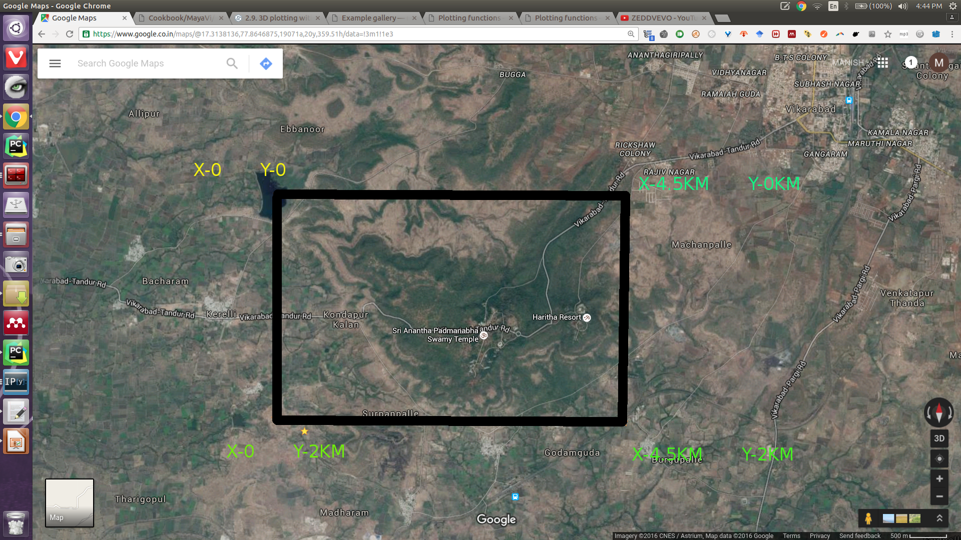
Z is also arranged in the exact same way. If you imshow(z), you wil get the elevation map exactly corresponding to the way it is depectied above.

The true LAT, LONG cords look somewhat like this.

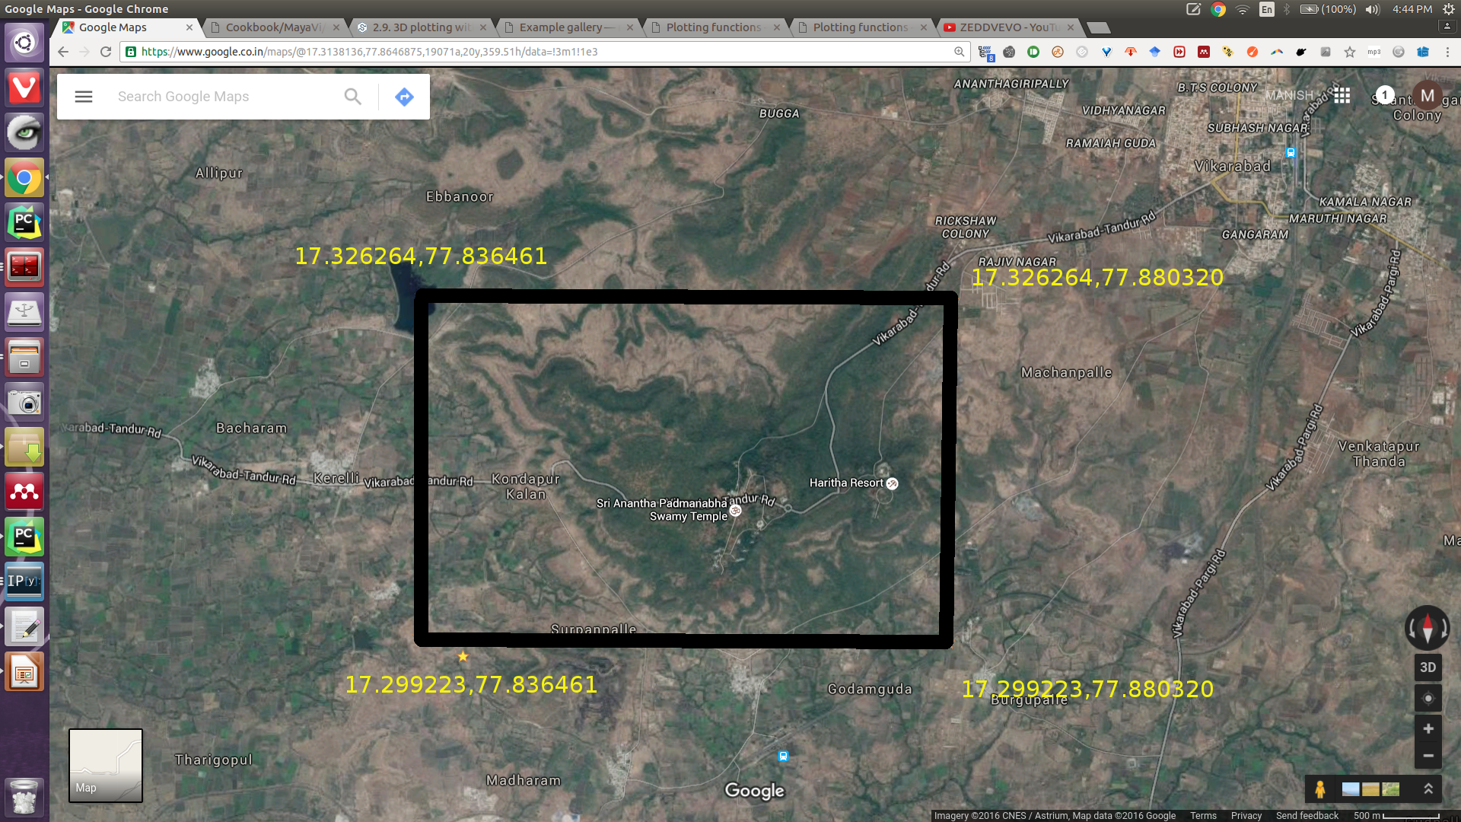
But, the problem in rendering it in 3D in mayavi, is that, in the cordinate reference fram, the origin should be at bottom left. Not at top left. This makes the Y cordinates inverted. So, the depth map would be upside down flipped version of the true data.
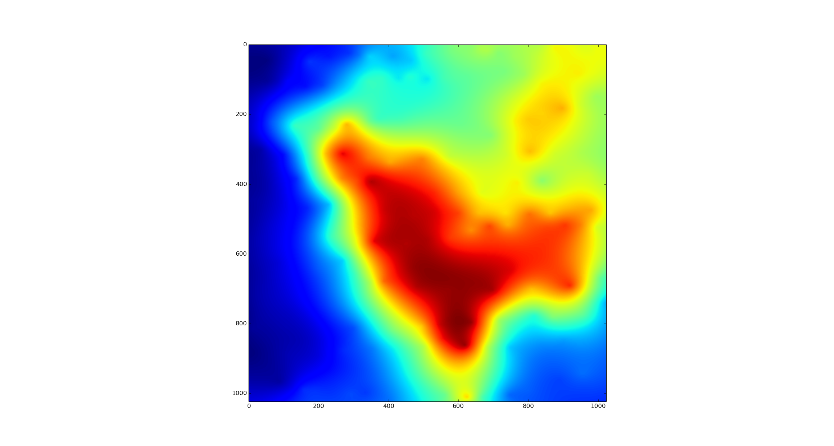

This is how the true depth map looks like, considering a NEWS same reference.

But, this is how the MAYAVI engine plots it like.

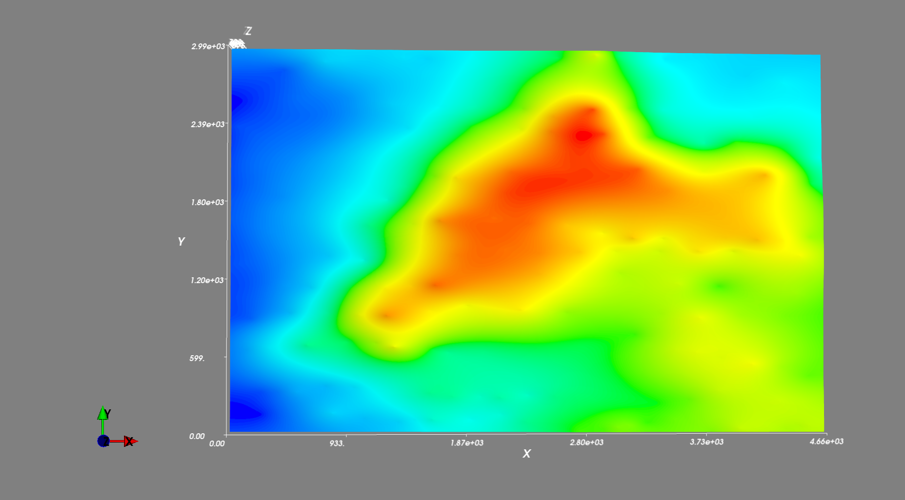
Clearly, its flipped upside down.

We can correct it by subtracting from Y, the maximum of Y itself.

